LAB REPORT实验报告
Lab Title | Doubly Linked List |  |  |  | Lab No. | 08
Stud. Name | Jiang Yunxiang | Major | CST |  | Class
Student ID | 2022102330 |  | Date | 4/14
Lab description/objectives:
a) A doubly linked list is a list in which each structure contains a pointer to both the following and previous structures in the list. Define an appropriate template for a doubly linked list of names and telephone numbers.
b) Using the template defined in a), modify Program 13.3 pgm13-3.c to list the names and phone numbers in reverse order.
Source code:
（Paste the source code here）
#include <stdio.h>
#define MAXNAME 30
#define MAXPHONE 15

struct TeleType {
char name[MAXNAME];
char phoneNum[MAXPHONE];
struct TeleType* next;
struct TeleType* prior;
};

void display(struct TeleType* contents)
{
while (contents != NULL) {
printf("%-30s %-20s\n", contents->name, contents->phoneNum);
contents = contents->next;
}
}

void reverse_display(struct TeleType* contents)
{
while (contents != NULL) {
printf("%-30s %-20s\n", contents->name, contents->phoneNum);
contents = contents->prior;
}
}

int main()
{
struct TeleType t1 = { "Acme, Sam", "(555) 898 2392" };
struct TeleType t2 = { "Dolan, Edith", "(555) 682 3104" };
struct TeleType t3 = { "Lanfrank, John", "(555) 718 4581" };
struct TeleType* first;
struct TeleType* last;

first = &t1; //定义第一个指针
t1.next = &t2;
t2.next = &t3;
t3.next = NULL;

last = &t3; //定义第二个指针
t3.prior = &t2;
t2.prior = &t1;
t1.prior = NULL;

display(first);
printf("\n");
reverse_display(last);

return 0;
}

Program outputs:
（Paste the screenshot of program output here）
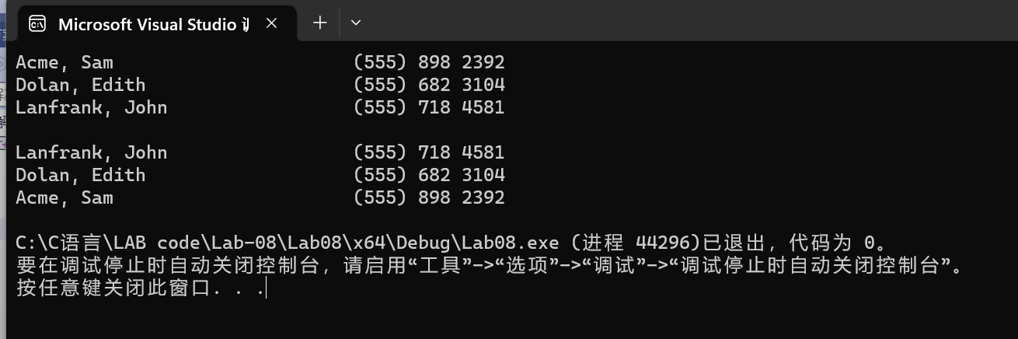
Discussion:
1．Most difficult parts
（What were the most difficult parts of your program to implement?）
Nope
2．Bugs and/or Errors
(List all the program bugs/errors you encountered and how you corrected them.)
Nope

